**Questions**

1. What is our independent variable? What is our dependent variable?

The independent variable is the colour of the words being shown, which can be a congruent color (when the color matches the word), or an incongruent color (when the color differs from the color spelled out). The dependent variable is the time recorded to name the ink color.

1. What is an appropriate set of hypotheses for this task? What kind of statistical test do you expect to perform? Justify your choices.

I would expect that the reaction time is higher when we need to ignore the letters of a word and focus only on color, as our brain is not used to doing that. The null hypothesis then, is that the reaction time for the incongruent sample in the general population will be less than or equal to the reaction time for the congruent sample. The alternate hypothesis will be that the reaction time for the incongruent sample in the general population will be larger than for the congruent sample.

Ho: **μ** <= 0

Ha: **μ** > 0

The test is ‘repeated-measures’ test, dependent on the ‘recorded time’ variable.

The t-test is appropriate in this case because we don’t know the mean or standard deviation of the population.

It will be a one tailed dependent t-test in the positive direction as I expect the incongruent colors to slow down (increase) the reaction time. This will be expressed by out t-stat being higher than the t-critical value, at alpha = 0.05.

1. Report some descriptive statistics regarding this dataset. Include at least one measure of central tendency and at least one measure of variability.

This dataset was made up of a set of paired samples, each with n = 24

The mean of the congruent sample results was: 14.05

The mean of the incongruent sample results was: 22.02

The mean of the differences between the 2 samples was: 7.96

The standard deviation of the congruent sample results was 3.56

The standard deviation of the incongruent sample results was 4.80

The standard deviation of the differences between the 2 samples was: 4.86

1. Provide one or two visualizations that show the distribution of the sample data. Write one or two sentences noting what you observe about the plot or plots.

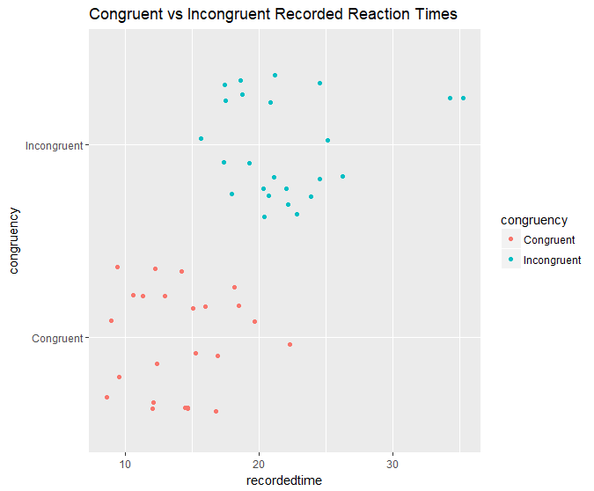

The above plot shows clearly that the recorded times for the incongruent results were higher, with the fastest results matching the slowest results from the congruent sample.

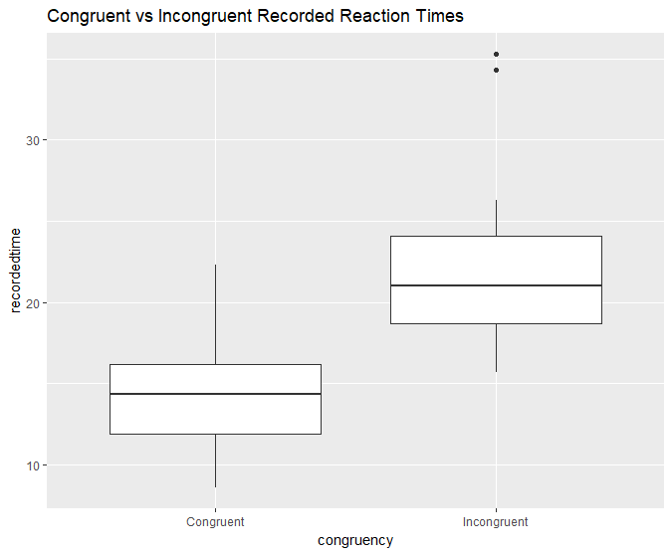

The above plot shows the distribution of results in each sample group, with the congruent group having a small distribution, and the incongruent having a little more variation. The two outliers just underline the fact that the incongruent test plays tricks with our brain, since there were no outliers in the congruent group.

1. Now, perform the statistical test and report your results. What is your confidence level and your critical statistic value? Do you reject the null hypothesis or fail to reject it? Come to a conclusion in terms of the experiment task. Did the results match up with your expectations?

For a 95% CI (alpha = 0.05), the t-critical value is 1.71

I calculated a t-stat of 8.02

The 95% CI values were (6.26,9.67)

The R2 value was: 0.74, which tells us that a very high percentage (74) of the variability we saw in results was due to the independent variable.

Because the t-stat is higher than the t-critical value, I reject the null Hypotheses

(Ho: Ud <= 0)

And, as I had expected, the reaction time is higher for the incongruent sample.

(Ha: Ud > 0)

1. Optional: What do you think is responsible for the effects observed? Can you think of an alternative or similar task that would result in a similar effect? Some research about the problem will be helpful for thinking about these two questions!

I think our brain function is responsible, as it is programmed to recognize any text as words, and I’m guessing the part of our brain that reads words works faster than the part that recognizes color, so when we want to override the reading part, our brain needs to stall for a second while it recognizes the color.

As far as alternative tasks, it would have to be some other test that tries to override a ‘default’ setting in our brain, for example another similar task would be to identify arrows that point one direction but say another.

**Resources Used**

<https://onlinecourses.science.psu.edu/stat500/node/51>

<https://libguides.library.kent.edu/SPSS/PairedSamplestTest>